**Project Requirement and Specification**

on

**Voice based Email service for visually challenged people**

(CSE 4th Semester Mini project )

2020-2021



University Roll no.: Submitted by:

2014407 JITENDRA SINGH

Section:

G

**DEPARTMENT OF COMPUTER SCIENCE AND ENGINEERING**

# GRAPHIC ERA UNIVERSITY, DEHRADUN

**---------------------------CONTENTS-----------------------**

**1.1ABOUT PROJECT--------------------------------------**

**1.2 METHODOLOGY-----------------------------------------------------------**

**1.3 APPLICATION-------------------------------------**

**1.4 SYSTEM REQUIREMENT--------------------------**

## 1.5 MODULE REPRESENTATION------------------- 1.6 DATA FLOW DIAGRAM---------------------------1.7 REFERENCE----------------------------------------------

----------------------------------------------------------------------

### 1.1About Project

This application will be a web-based application for visually impaired persons using IVR- Interactive voice response, thus enabling everyone to control their mail accounts using their voice only. The system will prompt the user with voice commands to perform certain action and the user will respond to the same. **The main benefit of this system is that the use of keyboard is completely eliminated, the user will have to respond through voice and mouse click only.**

### 1.2 Methodology

Talking about the features of the voice based mail, a user can send the mail by his/her voice. Program will ask the user to send the mail and the user will speak the name whom he/she wants to send the mail. It will ask the receiver name, subject and message and if the name is not found in the email dictionary it will speak that name is not found. And if is able to find the name then it will send the mail through SMTP server.

Make sure that on the sender's side , we need to give the access to less secure app in sender's Gmail account .

### 1.3 ****Application:****

This project is proposed for the betterment of society. This project aims to help the visually impaired people to be a part of growing digital India by using internet and also aims to make life of such people quite easy. Also, the success of this project will also encourage developers to build something more useful for visually impaired or illiterate people, who also deserves an equal standard in society..

### 1.4Requirement of Project

**1.4.1Hardware Requirement:**

* **PROCESSOR: INTEL® PENTIUM® CPU @ 2.0 GHZ**
* **RAM: 2 GB(MINIMUM)**
* **STORAGE: 50MB(MAXIMUM)**
* **OS: WINDOWS 10,8,7**

**1.4.2Software Requirement:**

* **PYCHARM**
* **PYTHON**
* **SPEECH RECOGNITION MODULE**
* **SMTPLIB MODULE**
* **PYTTSX3 MODULE**
* **PYAUDIO**
* **Google Speech-to-text and text-to-speech APIs.**
* **Make credentials of sender’s gmail account**
* **--upgrade google-api-python-client google-auth-httplib2 google-auth-oauthlib**

**Creating Credentials steps:**

To configure the OAuth consent screen:

1. Open the [Google Cloud Console](https://console.cloud.google.com/).
2. Next to **Google Cloud Platform**, click the Down arrow arrow_drop_down and select a project.
3. At the top-left corner, click Menu menu.
4. Click **APIs & Services** > **Credentials**. The credential page for your project appears.
5. Click **Configure Consent Screen**. The "OAuth consent screen" screen appears.
6. Click the user type for your app. If you're running a Quickstart, select **Internal**.

**Note:** For company-internal apps, scopes aren't listed on the consent screen and use of restricted or sensitive scopes does not require further review by Google.

1. Click **Create**. A second "OAuth consent screen" screen appears.
2. Fill out the form:
   * If you're running a quickstart, enter "Quickstart" in the **App name** field.
   * If you're running a quickstart, enter your personal email address in the **User support email** field.
   * If you're running a quickstart, enter your personal email address in the **Developer contact information** field.
3. Click **Save and Continue**. The "Scopes" page appears.
4. (optional). If you are creating an external app, click **Add or Remove Scopes**. The "Update selected scopes" page appears.
5. (optional). For each API you intend to use in your app, check the scopes to use in your app.

**Note:** Some scopes require your app to go through a security assessment or app verification process. For help picking the correct scopes for your app, refer to [Identify scopes](https://developers.google.com/workspace/guides/identify-scopes).

1. (optional) Click **Update**. A list of scopes for your app appears. If any scopes appear under the heading "Your sensitive scopes" or "Your restricted scopes," refer to [Identify scopes](https://developers.google.com/workspace/guides/identify-scopes).
2. Click **Save and Continue**. The "Edit app registration" page appears.
3. Click **Save and Continue**. The "OAuth consent screen" appears.
4. Click **Back to Dashboard**.

### Create Desktop application credentials

If you're creating Desktop application credentials:

1. Click **Create**. The OAuth client created screen appears. This screen shows the Client ID and Client secret.
2. Click **OK**. The newly created credential appears under "OAuth 2.0 Client IDs."
3. Click the download button to the right of the newly-created OAuth 2.0 Client ID. This copies a client secret JSON file to your desktop. Note the location of this file.
4. (Optional) If you are creating credentials for a quickstart, rename the client secret JSON file to "credentials.json".

**ABOUT SMTP SERVER:** 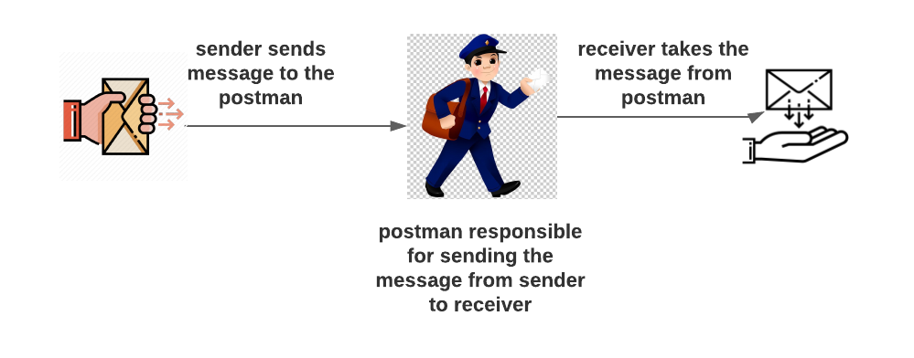

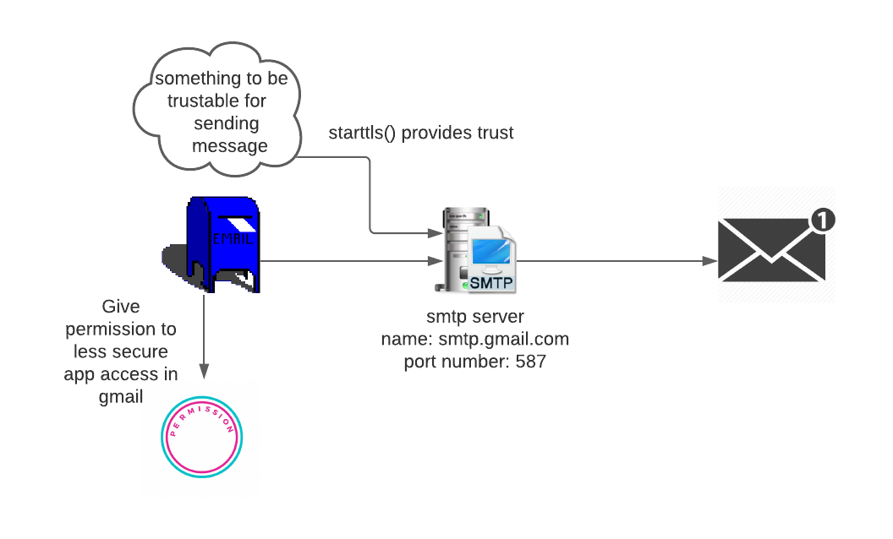**1.5 Representation of Module of Project in table:**

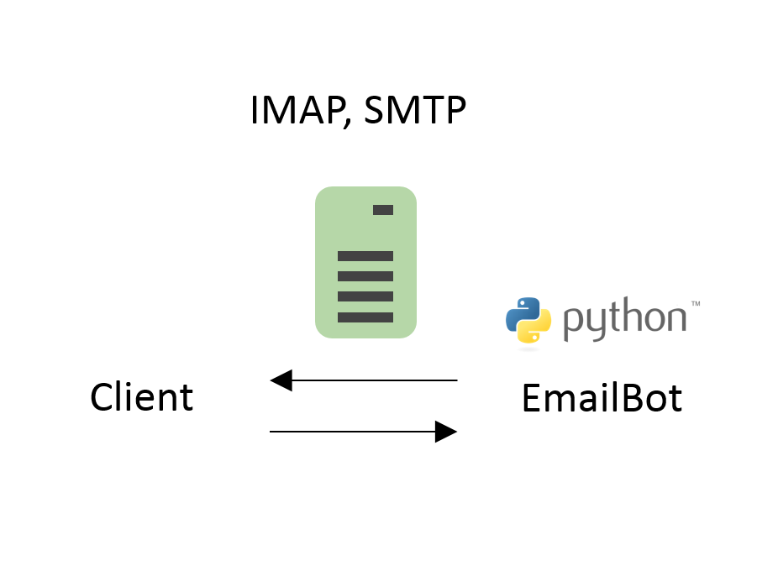

### 1.6 FLOWCHART

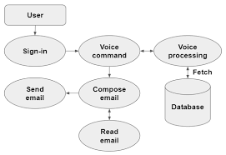

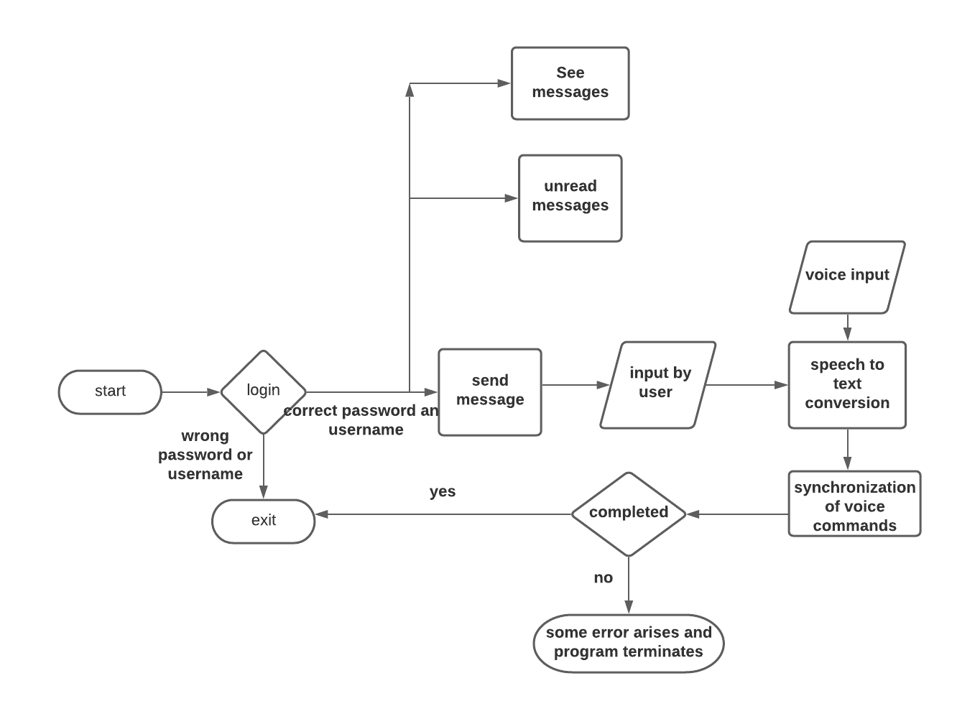

**OUTPUT:**

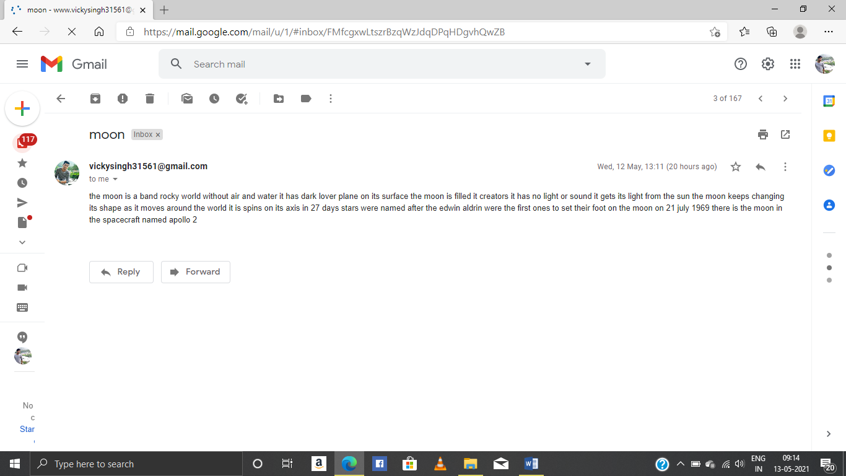

# REFERENCE

1. GEEKS FOR GEEKS.
2. W3 SCHOOL.
3. STACK OVERFLOW.
4. Jagtap Nilesh, Pawan Alai, Chavhan Swapnil and Bendre M.R.. “Voice Based System in Desktop and Mobile Devices for Blind People”. In International Journal of Emerging Technology and Advanced Engineering (IJETAE), 2014 on Pages 404-407.

5.Ummuhanysifa U.,Nizar Banu P K , “Voice Based Search Engine and Web page Reader”. In  
International Journal of Computational Engineering Research (IJCER). Pages 1-5.

1. <https://cloud.google.com/speech/docs/getting-started>
2. https://developers.google.com/gmail/api/quickstart/python

**Source code is available at my Github Account:**

[All-projects/Email at main · 2606199/All-projects (github.com)](https://github.com/2606199/All-projects/blob/main/Email)

